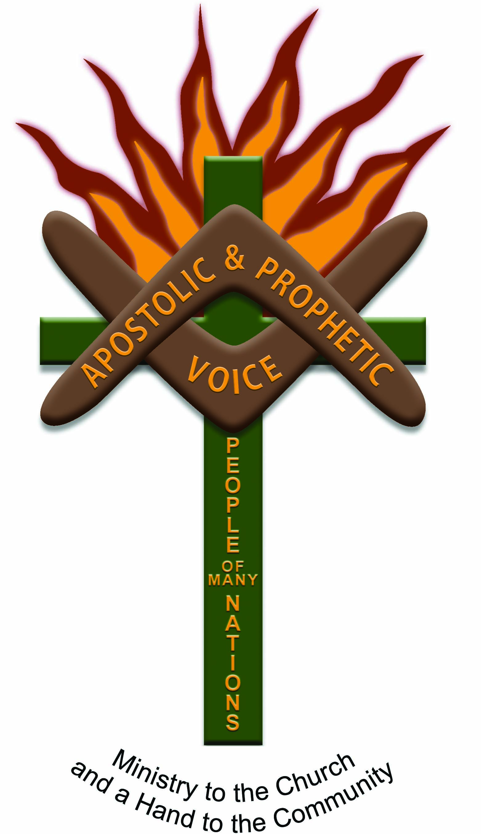

Spring Edition 2020

PO Box 3498
Toowoomba Qld 4350
Ps Ada Boland: 0499117346
Email: adaboland@outlook.com

A word in season: Revelations 19:7 “Let us be glad & rejoice and give Him Glory, for the marriage of the Lamb has come, and His wife has made herself ready.”

WHAT A beginning to 2020!
What a year! I cannot believe the pace and acceleration of the things of God. Seeing His
Plans, His Purposes, His
advancement of the Kingdom of Christ unfolding. I have had to stop and pinch myself at times and just stand amazed at the PROPHETIC WORDS that
have been spoken over my life probably 5 years ago coming to pass as God has begun to unfold them one at a time in such an appointed season as I stepped
out of the boat and followed
after HIS WHOLE WILL for my life.
YES! I have stumbled and fallen
short at times, but He is always
there to put me back on track and help me to stay focused on the BIGGER PICTURE. It is the
HOUR and the SEASON, to
align your life with the WILL of the FATHER, to be positioned and prepared for the days ahead. The days are going to
continue to be evil – but thank
you Lord that in the midst of dark
ages, the Glory of the Lord will
increase, and His Spirit will also increase to advance His
Kingdom. Many will come to
know Him and the Sons of God
will arise and take their place in this last great move of the Spirit
in the land down under, the Great Southland of the Holy Spirit - Australia. Be like Isaiah who said: “LORD HERE AM I – SEND ME.” Jesus spoke of his purpose in John 4:32 “But He said to them, “I have food to eat of which you do not know.” Verse 34: Jesus said to them, “My food is to do the WILL of Him who sent Me, and to finish HIS WORK.” Do not let procrastination or the things of this world STAGNATE what our Father has asked of you to be doing. Love & God Bless Ps. Ada. 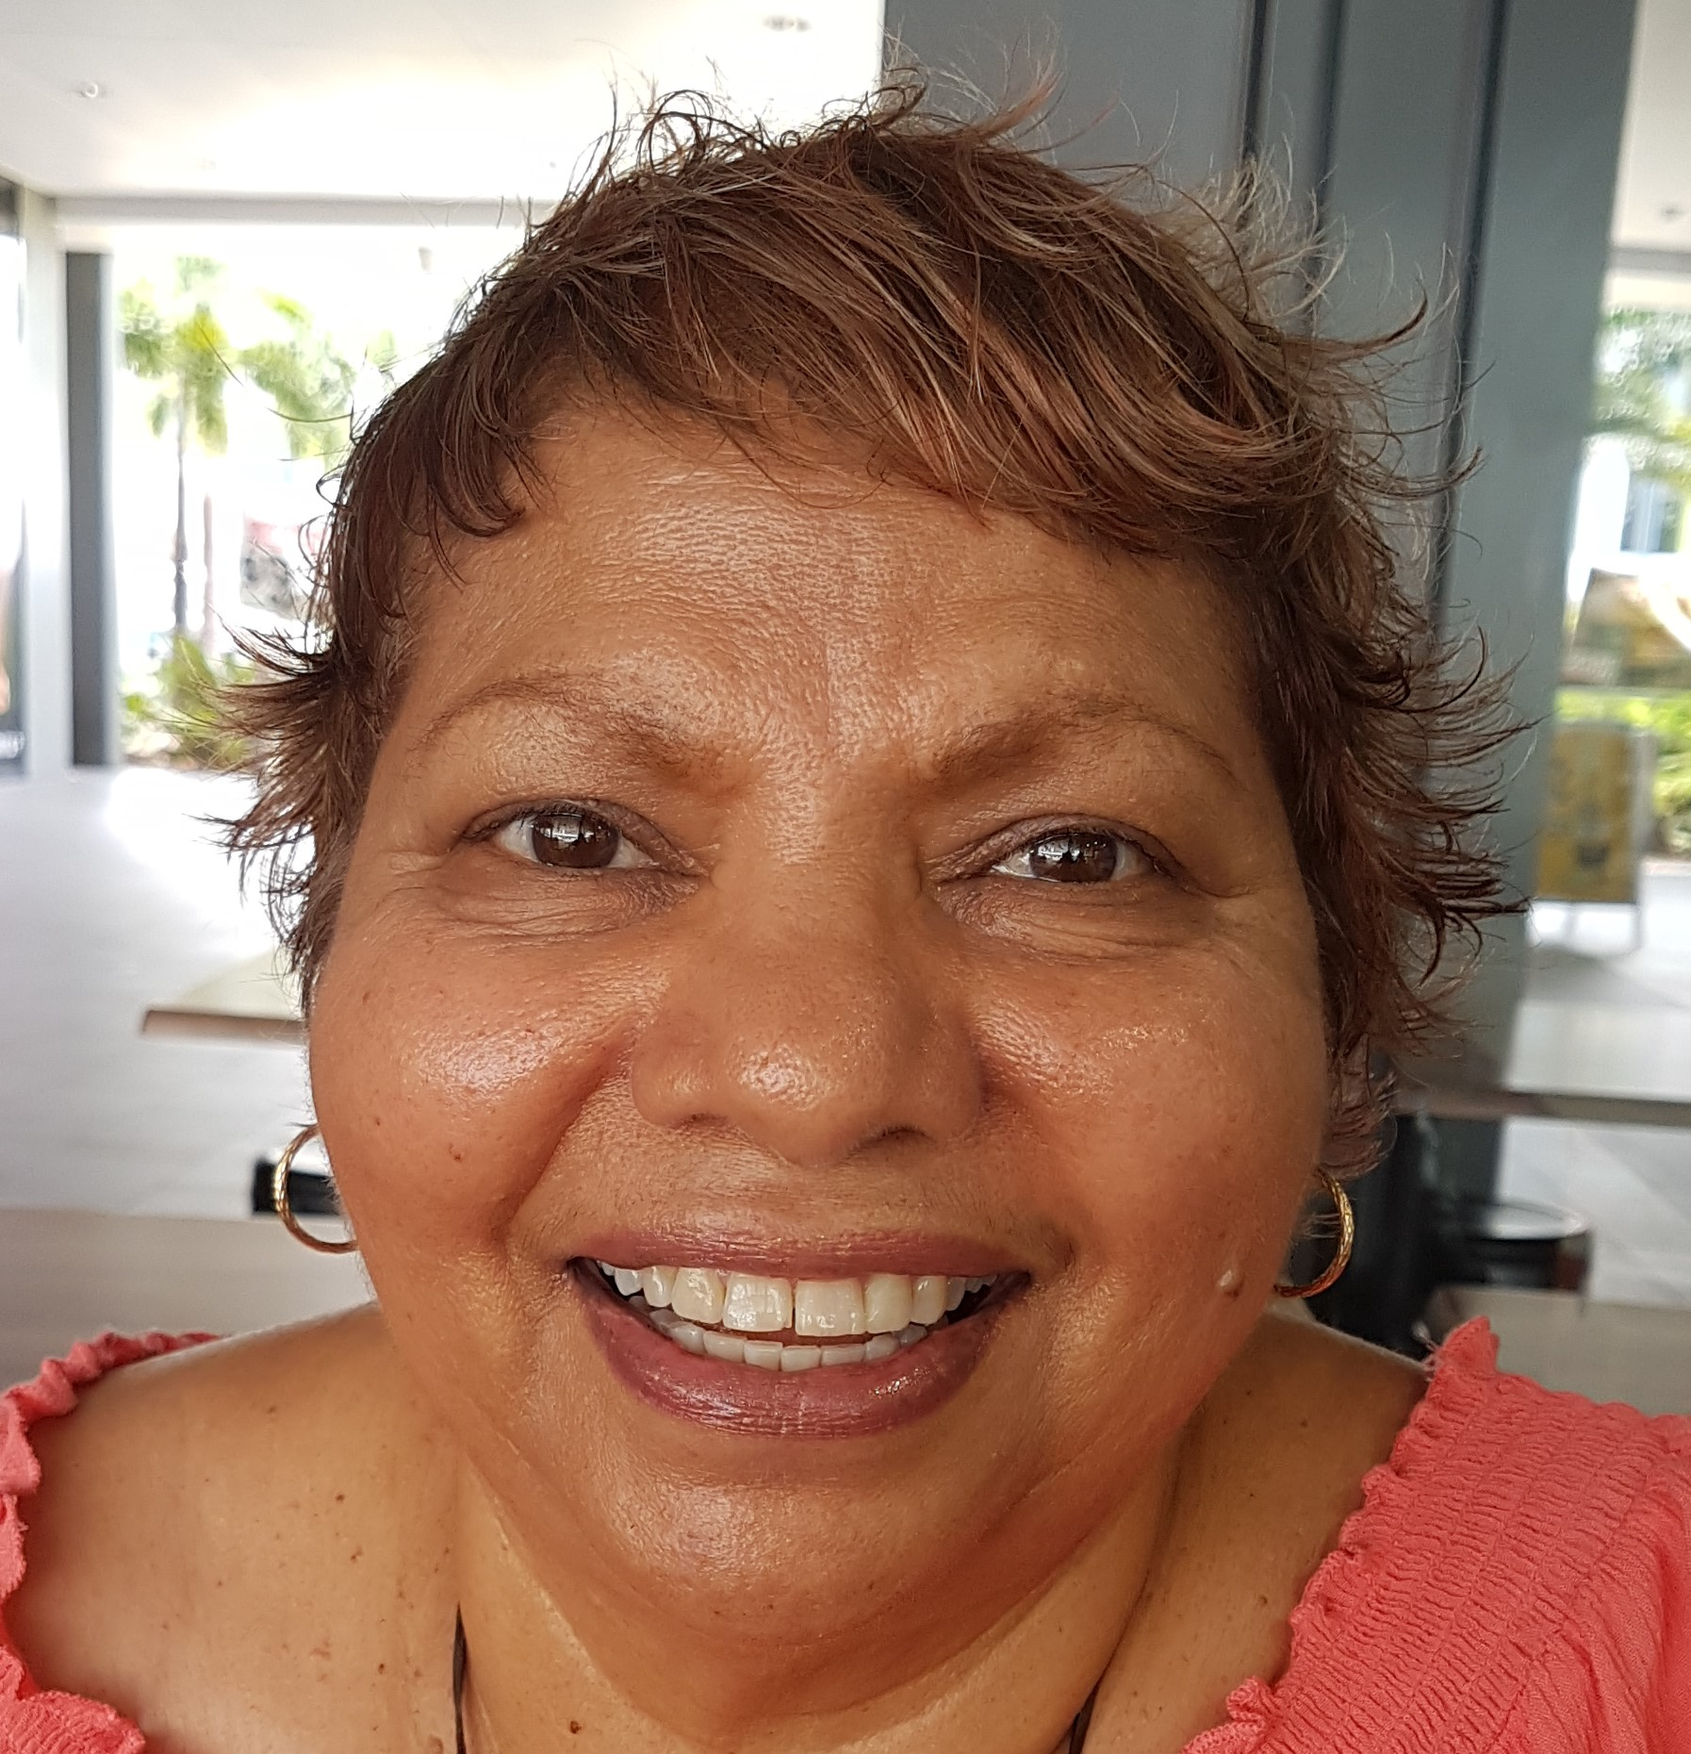

2020/2021 COMING EVENTS STAY CONNECTED FOR VENUES & DATES
- REGIONAL TEAM PARTNERSHIP TRAINING 2021: If you want to be on our team let us know. Call Wendy
- LOCAL TRAINING & EQUIPPING: School of the Spirit – November 20th – 22nd Zillmere Brisbane
- SOAR 2022 CONFERENCE TOOWOOMBA: Stay connected for details. (plan now to attend & partner with us to build His Kingdom on the Earth)
- Woman of Faith: Women’s Conference Fiji (be part of the team/join us) 17th-20th Sept 2021: still happening

Indigenous Apostolic

and Prophetic Voice

“it’s time the bride is making herself ready for the marriage supper of the lamb.”

Women of Faith South

Pacfic Islands Connections

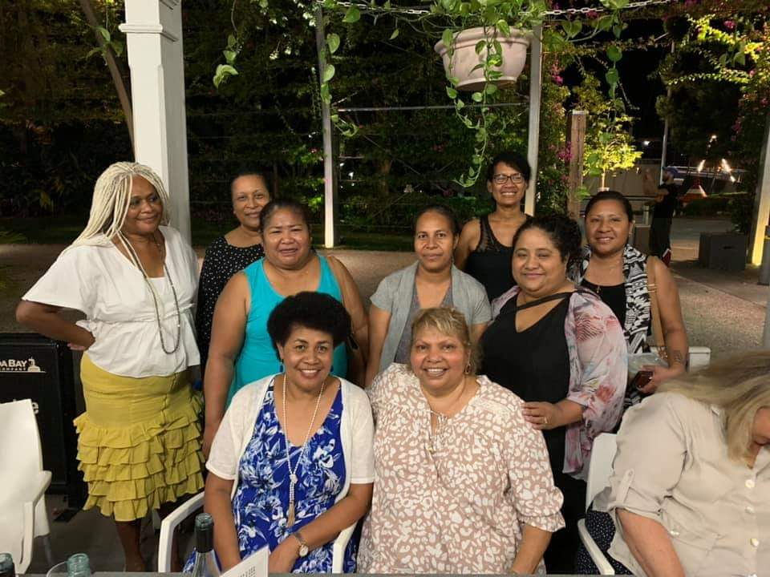

Prayer points
1. Please continue to cover Pastor Ada and regional teams & their leaders/families partnering with the ministry with prayers of protection and provision.
2. Now is a time of planning for the 2021 calendar for conferences, team training & equipping. In this time please pray that Ps Ada will hear from God about what He is saying regarding Strategic Places and partnerships with His Strategic Leaders.
3. Increase of Financial Partnerships & Sponsorships

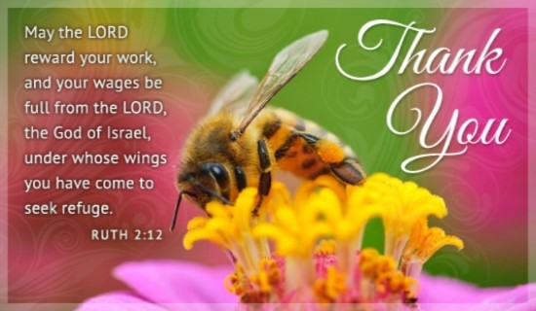

Note of thanks & appreciation

To all our financial supporters & generous givers, we want you to know that we are standing in prayer with you, your families & ministries that God will increase the fruits of your hands and multiply back to you to overflowing, pressed down and shaken together with His unlimited resources.

It is because of you all that we are where we are today, I am able to continue to do God’s work & keep my hands to the plow and not look back.

“BIG LOVE & BLESSINGS”

TOGETHER WE – THE CHURCH CAN MAKE A DIFFERENCE

We are looking forward with expectation and anticipation to the year ahead 2021/22 to see what God will unfold and what He has in store for us. If you would like to contact us regarding partnership, please give Wendy Nix Ps Ada’s (PA) a call on: 0417710418 or email: rawnix2@bigpond.com

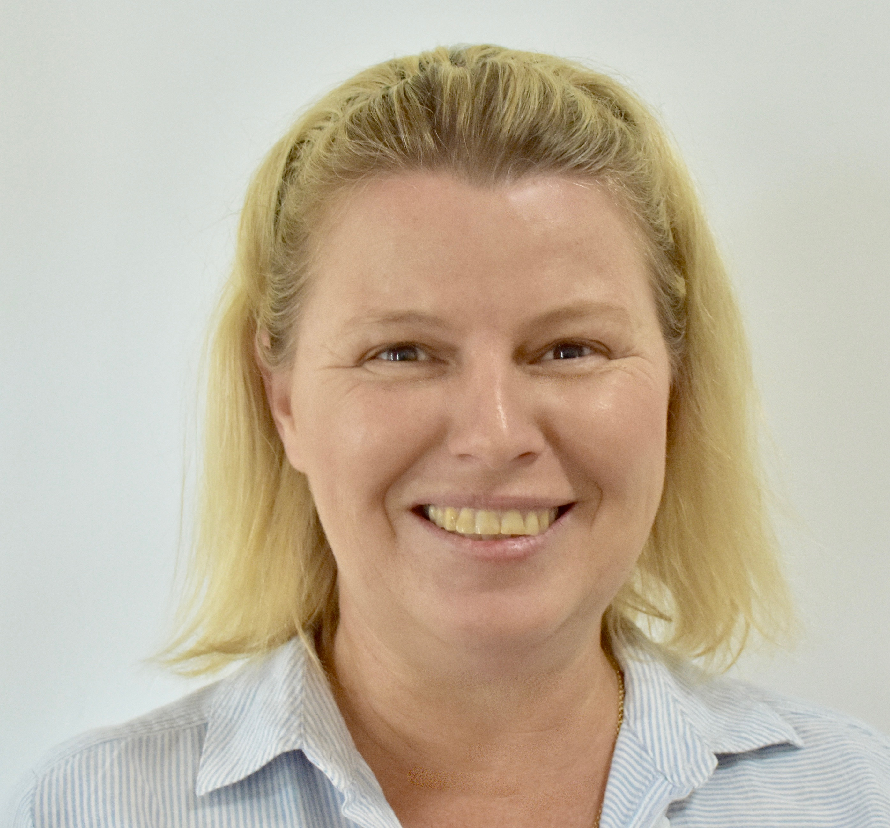

STILL TO COME

So much has happened, stay tuned as we prepare a collage of pics with all the new connections, the people the places and the faces.

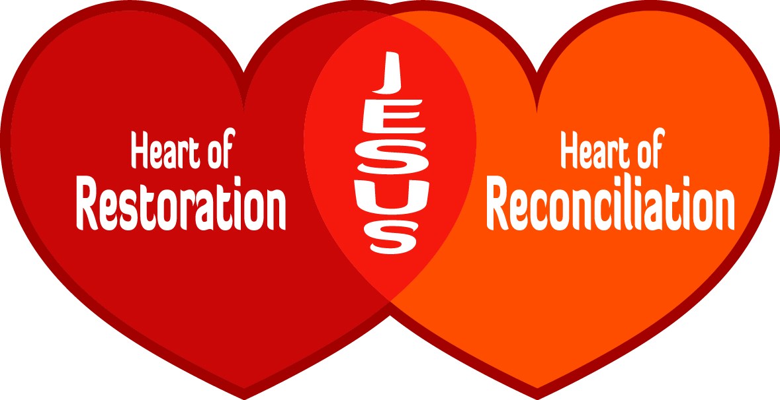

THANK YOU TO OUR PRAYER TEAM, WE ARE SO GRATEFUL FOR YOUR LOVE FOR GOD AND LOVE FOR PRAYING. A 3-FOLD CORD CANNOT BE BROKEN, WE STAND TOGETHER IN BELIEVING GOD TO LEAD & GUIDE US INTO ALL HE HAS FOR US IN REACHING OUR communities.

